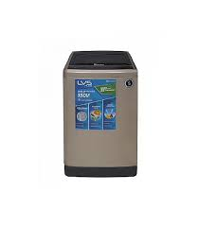

DWT-235 LVS

* 1 Year Warranty
* Washer & Spinner
* Single Waterfall
* Top Load
* **Rs.12,900**